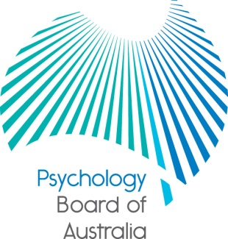

Communiqué

24 October 2014

The Psychology Board of Australia (the Board) is established under the Health Practitioner Regulation National Law, as in force in each state and territory (the National Law).
This communiqué highlights key issues from the 57th meeting of the Board on 24 October 2014.
At each meeting, the Board considers a wide range of issues, many of which are routine and are not included in this communiqué.

Call for applications for National Boards regulating health practitioners across Australia
Applications are now sought for appointments to upcoming vacancies for chairs (from practitioner members), practitioner members and community members on National Boards regulating health practitioners including the Psychology Board of Australia.
National Board appointments are made by the Australian Health Workforce Ministerial Council, under the Health Practitioner Regulation National Law as in force in each state and territory. Terms are expected to commence around August 2015. Appointments and reappointments are for up to three years as decided by the Ministerial Council.
More information about the roles and the application process is included in the application form and guide. These can be downloaded from the Board member page on the AHPRA website.
For general enquiries, email boardappoint@ahpra.gov.au
Applications close by 5.00pm AEDT on Wednesday 12 November 2014.
Reminder: renewal of registration for 2014/15
The Board encourages psychologists to renew their registration with the Board by 30 November. The quickest and easiest way to renew registration is online.
The registration renewal date for psychologists with general or non-practising registration is 30 November 2014. Renewal applications received during December will incur a late payment fee.
Under the National Law1, practitioners who do not renew their registration within one month of their registration expiry date must be removed from the Register of Psychologists. Their registration will lapse and they will not be able to practise psychology in Australia. A fast track application can be made, but only during January. The practitioner cannot practise until the application is processed and the national register is updated.

Psychologists should act now if their contact information has changed to not miss future reminders to renew. To update contact details visit the Board’s website and use the appropriate link under online services for practitioners. A user ID and secure password is needed. Practitioners who have forgotten their user ID can complete a web enquiry form. Select ‘Online Services - Practitioner' as the category type.

Approved programs of study
Under section 49 of the National Law, the National Board requires accreditation reports from the Australian Psychology Accreditation Council (APAC) before approving the accredited programs of study as providing a qualification that will lead to registration.
At this meeting the Board approved APAC-accredited courses from Latrobe University and Monash University. The Board also approved the discontinuation of a number of courses across the country in accordance with s.51(2) of the National Law, including courses at Edith Cowan University and Monash University.
The updated list of Board-approved qualifications will be published soon on the Board’s website at: www.psychologyboard.gov.au/Accreditation.aspx.

Perth forum
The Board is holding a public forum in Perth on Thursday 27 November 2014 and psychologists are invited to attend.

It is essential to RSVP to attend this event as places are limited. Please note that walk-ins will not be able to be accommodated, so please make sure to RSVP soon if you would like to attend.

Date: Thursday 27 November 2014

Time: 5.00pm to 7.00pm

Venue: Rydges Perth
815 Hay Street (corner King and Hay Streets), Perth
T +61 3 9263 1800
W www.rydges.com

RSVP: 17 November 2014
e: psychologyforum@ahpra.gov.au

Professor Brin Grenyer
Chair
Psychology Board of Australia
29 October 2014

