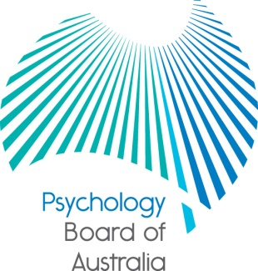

Communiqué

19 December 2014

The Psychology Board of Australia (the Board) is established under the Health Practitioner Regulation National Law, as in force in each state and territory (the National Law).
This communiqué highlights key issues from the 59th meeting of the Board on 19 December 2014.
At each meeting, the Board considers a wide range of issues, many of which are routine and are not included in this communiqué.

Consultation paper released - Review of the Provisional registration standard and Guidelines for the 4+2 internship program

The Board has published a consultation paper seeking input on proposals to update the Provisional registration standard and the Guidelines for the 4+2 internship program.

The Board is asking the community and practitioners to have their say on the standard that psychologists must meet for entry into the profession as a provisional psychologist; and the requirements for developing the knowledge, skills and competence required for entry into general registration via the 4+2 internship program pathway.

The consultation paper also includes exposure drafts of the General registration standard and the Policy on recency of practice requirements which have been revised following public consultation in 2014, and the proposed suite of reporting and recording forms to support the 4+2 internship program.

The Board is keen to hear from all stakeholders on any aspect of the proposed revisions to the standard or guideline. The consultation paper is available under Current consultations and the Board is accepting submission until Friday 27 February 2015.

National Psychology Examination – updated reading list
The Board has published an updated Exam Reading List (December 2014) which can be found on the Board’s website. The next window to sit the examination is between Friday 6 February and Friday 27 February 2015 and candidates can register through the examination portal from Monday 22 December 2014 to Friday 23 January 2015.
Approved programs of study
Under section 49 of the National Law, the National Board requires accreditation reports from the Australian Psychology Accreditation Council (APAC) before approving the accredited programs of study as providing a qualification that will lead to registration. At this meeting the Board approved APAC-accredited courses from Australian Catholic University, Central Queensland University, Charles Sturt University, Federation University Australia, Flinders University, Griffith University, James Cook University, Macquarie University Monash University, Murdoch University, Queensland University of Technology, Southern Cross University, Swinburne University of Technology, University of Adelaide, University of Melbourne, University of New England, University of New South Wales, University of the Sunshine Coast, University of Wollongong, Victoria University.

The Board also approved the discontinuation of a number of courses across the country in accordance with s.51(2) of the National Law, including courses at Bond University, Central Queensland University, Deakin University, Federation University Australia , Flinders University, Griffith University, University of Canberra, University of New England , University of New South Wales, University of Western Sydney, James Cook University , Macquarie University, University of New South Wales, University of Wollongong, Victoria University. Students currently enrolled in these courses will still have their qualification recognised for registration once they graduate, but there will be no new enrolments for these courses.

An updated list of Board-approved qualifications will soon be published under Accreditation on the Board’s website

Professor Brin Grenyer
Chair, Psychology Board of Australia
5 January 2015

