Ms Rachel Phillips

Psychology Board of Australia
GPO Box 9958
Melbourne Vic 3001

31October 2018

By email: psychconsultation@ahpra.gov.au

Dear Rachel

Consultation –Area of Practice Endorsement Registration Standard
Thank you for the opportunity to comment on the Psychology Board of Australia’s consultation on a ‘draft Area of practice endorsements registration standard (AoPE standard)’.
We note from the consultation document that the purpose of the consultation is ‘to ensure the AoPE standard aligns with the new accreditation standards’ and that ‘the proposed AoPE standard and guidelines have been revised to recognise.…stand-alone programs’.
APAC supports this approach and of the two options provided in the paper APAC supports Option 2 – New AoPE standard and guidelines.

Yours sincerely

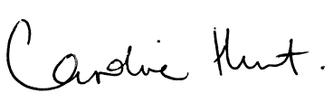
Professor Caroline Hunt
Chair

