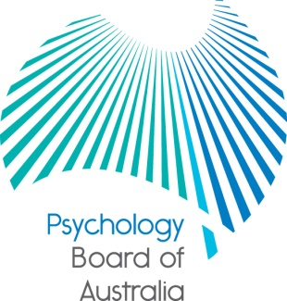

Communiqué

6 July 2017
The Psychology Board of Australia (the Board) is established under the Health Practitioner Regulation National Law (National Law), as in force in each state and territory. At each meeting, the Board considers a wide range of issues, many of which are routine and are not included in this communiqué.
This communiqué highlights key issues from the 86th meeting of the Board on 30 June 2017.
Public consultation on reviewing the National psychology examination curriculum due for release in July
The Board has now published Consultation paper 28: National psychology examination curriculum review. The curriculum was published in 2012, with the national psychology examination coming into effect on 1 July 2013. The Board has determined to review the curriculum every three to five years in keeping with good regulatory practice. The aim of the review is to ensure that the examination:
- assesses that the right competencies for general registration as a psychologist in Australia remain fit-for-purpose
- is aligned with the newly published International declaration of core competencies in professional psychology (2016), and that the
- curriculum is up-to-date with advances in the field of psychology.
This is a review of the examination curriculum (and the documents that support the curriculum) only. The following documents are identified for review:
- the National psychology examination recommended reading list
- the National psychology examination curriculum
- the Assessment domain additional resources document
- A brief orientation to the National psychology examination, and
- the section of the guidelines (p. 4-5) that relates to the examination curriculum.

The public consultation paper is available under Current consultations on the Board website. The consultation is open for feedback between 7 July 2017 and 1 September 2017.

Board Director nominee to APAC
The Board is please to advise that, following a competitive selection process, Professor Alison Garton has been nominated by the Board to serve as a director on the Australian Psychology Accreditation Council (APAC) Board.

The Board nominates four directors (three practitioner members and one community member) to serve on the APAC Board. The APAC Board has a total of 12 directors. The Australian Psychological Society (APS) and Heads of Departments and Schools of Psychology Association (HODSPA) nominate four persons each by their own separate processes.

Professor Garton’s appointment will begin in August 2017.

Further information
The Board publishes a range of information for psychologists on its website at http://www.psychologyboard.gov.au/. For more information about registration, notifications or other matters relevant to the National Scheme also refer to information published on www.ahpra.gov.au, send an online enquiry form or contact AHPRA on 1300 419 495.

Professor Brin Grenyer
Chair
Psychology Board of Australia
6 July 2017

