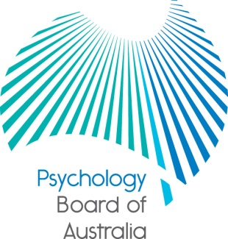

Communiqué

29 July 2016
The Psychology Board of Australia (the Board) is established under the Health Practitioner Regulation National Law, as in force in each state and territory (the National Law). At each meeting, the Board considers a wide range of issues, many of which are routine and are not included in this communiqué.
This communiqué highlights key issues from the 76th meeting of the Board on 29 July 2016.
International Congress of Psychology
The 31st International Congress of Psychology was recently held in Yokohama, Japan. Members of the Board attended the congress as well as other key meetings associated with the event. The highlights included:
Asia-Pacific Psychology Leadership Forum
On Sunday 24 July members of the Board attended the inaugural Asia Pacific Leadership Forum. The forum focused on building knowledge and understanding of psychology across the Asia Pacific region. A key outcome from the forum was agreement to commit to the development of an Asia Pacific Psychology alliance to pursue the goals arising from the Yokohama declaration.

International Project on Competence in Psychology - The Declaration and final report
The Declaration was formally launched at the International Congress of Psychology. The International Association of Applied Psychology and International Union of Psychological Science have also adopted the Declaration as part of their official meetings in Yokohama. After three years of work and broad consultation, the International Declaration on Competences in Professional Psychology along with a final report has been published – these documents can be downloaded at www.psykologforeningen.no/foreningen/english/ipcp.

International regulators

Members of the Board met with international regulators to strengthen relationships on issues of mutual interest. A particular focus of these discussions was to explore opportunities for mutual recognition of registration and mobility between the different countries.

Public consultation on a guideline for the transitional program
The Board has published Consultation paper 27: Proposed guideline for transitional programs for overseas trained psychologists.
Since 1 July 2013 overseas trained psychologists have completed the three-month transitional program in order develop and demonstrate their skills in legal, ethical, professional and cultural matters specific to practising psychology in Australia, and to prepare for sitting the National Psychology Examination. This helps ensure that all psychologists who are registered in Australia are able to practice ethically and competently in the Australian context.
The requirements for the transitional program are set out in the registration standard for general registration. The proposed guideline would supplement the registration standard and provide extra guidance about the requirements to overseas trained psychologists and their employers and supervisors.
The Board is inviting comments from all interested parties, including the profession in Australia and overseas, employers, students, professional associations, education providers, government, consumers of psychology services and the general public.
The consultation paper is published under Current consultations and the Board is accepting submissions until Wednesday 7 September 2016.
Email alert
We have recently been alerted that an email with the subject line: ‘AHPRA approval of revised general registration standard’ seemingly from the email address noreply@psychologyboard.gov.au has been received by some psychology practitioners.

The email is a ‘phishing attack’ - a scam email purportedly sent from a legitimate business (in this case the Psychology Board of Australia), which tries to trick you into giving personal information or may infect your computer, usually through you clicking on a link or by downloading a document.

Please be advised that AHPRA did not send this email and our email system is not compromised.

If you have received an email like the one described above, please delete it. Or if you have received a suspicious looking email and you are not sure whether to open it, please contact AHPRA on 1300 419 495.

You can learn more about phishing emails and how to identify them at the Australian Government’s ‘Stay smart online’ website.

Professor Brin Grenyer
Chair
Psychology Board of Australia
03 August 2016

