Psychology Board of Australia

Registrant Data

Reporting Period: March 2016

Table of contents
Introduction 3
Principal Place of Practice 4
1. Registration type 4
Endorsements 5
2. Endorsement by PPP 5
3. Number of endorsements 5
Supervisors 7
4. Board-approved supervisors 7
5. Registrar program supervisors 8
6. Approved supervisors of provisional psychologists 9
Age Group 10
7. Registration type by age group 10
Gender 10
8. Registration type 10
9. Percentage 10

Introduction
The role of the Psychology Board of Australia (the Board) includes:
- registering psychologists and provisional psychologists
- developing standards, codes and guidelines for the psychology profession
- handling notifications, complaints, investigations and disciplinary hearings
- overseeing the assessment of overseas trained psychologists who wish to practise in Australia, and
- approving accreditation standards and accredited courses of study.
The Board’s functions are supported by the Australian Health Practitioner Regulation Agency (AHPRA). For information about legislation governing our operations see About AHPRA at www.ahpra.gov.au/About-AHPRA/What-We-Do/Legislation.aspx.
The Board has analysed its registration data and produced a number of statistical breakdowns about registrants to share with the profession and community. The Board shares these breakdowns regularly.
For more information on psychology registration, please see the Board’s website www.psychologyboard.gov.au/Registration.aspx

Principal Place of Practice
Principal Place of Practice (PPP) is the address declared by the psychologist to be the address at which he or she is predominantly practising the profession. If the psychologist is not practising the profession or is not practising predominantly at one address the Principal Place of Practice may be the psychologist’s principal place of residence.
The ‘No PPP’ column in the tables on the following pages represents psychologists who do not have an Australian Principal Place of Practice recorded on the register usually because they are currently residing overseas or who have not provided a valid PPP.

- Registration Type
  - Registration type by principal place of practice
Registration Type | ACT | NSW | NT | QLD | SA | TAS | VIC | WA | No PPP | Total
General | 729 | 9,096 | 199 | 4,740 | 1,384 | 493 | 7,442 | 2,803 | 362 | 27,248
Provisional | 100 | 1,334 | 29 | 950 | 190 | 63 | 1,310 | 584 | 12 | 4,572
Non-practising | 38 | 565 | 2 | 273 | 89 | 19 | 339 | 174 | 157 | 1,656
Total | 867 | 10,995 | 230 | 5,963 | 1,663 | 575 | 9,091 | 3,561 | 531 | 33,476

  - Registration by principal place of practice percentages
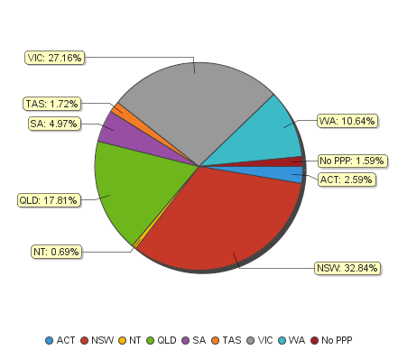

Endorsements
- Area of practice endorsements by PPP
  - Area of practice endorsements by state or territory
Area of practice | ACT | NSW | NT | QLD | SA | TAS | VIC | WA | No PPP | Total
Clinical neuropsychology | 6 | 149 | 1 | 94 | 22 | 9 | 277 | 33 | 10 | 601
Clinical psychology | 204 | 2,270 | 31 | 1,122 | 573 | 166 | 1,841 | 1,011 | 77 | 7,295
Community psychology |  | 7 |  | 3 | 1 |  | 35 | 9 | 1 | 56
Counselling psychology | 10 | 218 | 1 | 73 | 12 | 6 | 469 | 137 | 10 | 936
Educational and developmental psychology | 9 | 162 |  | 99 | 36 | 20 | 208 | 69 | 7 | 610
Forensic psychology | 11 | 219 | 7 | 68 | 33 | 10 | 149 | 43 | 4 | 544
Health psychology | 5 | 69 | 1 | 53 | 25 | 9 | 145 | 8 | 3 | 318
Organisational psychology | 17 | 146 | 1 | 80 | 51 | 2 | 137 | 40 | 5 | 479
Sport and exercise psychology | 5 | 21 | 1 | 26 | 8 | 4 | 22 | 6 |  | 93
Total | 267 | 3,261 | 43 | 1,618 | 761 | 226 | 3,283 | 1,356 | 117 | 10,932
* Note: The figures in table above show the total number of psychology area of practice endorsements recorded on the National Register. Psychologists who hold more than one endorsement are counted for each endorsement they hold. The number of individual psychologists who hold at least one area of practice endorsement after the close of business on 31 March 2016 was 9,907.

- Number of Endorsements
  - Number of endorsements held
 | 1 | 2 | 3 | 4 | 6 | Total
Number of endorsed psychologists | 8,964 | 873 | 60 | 9 | 1 | 9,907
% of endorsed psychologists | 90.48% | 8.81% | 0.61% | 0.09% | 0.01% | 100%
Number of psychologists with general registration (endorsed and non-endorsed) |  |  |  |  |  | 27,248
% of all general psychologists with one or more endorsement | 32.90% | 3.20% | 0.22% | 0.03% | <0.01% | 36.36%

  - Psychologists with one endorsement per registrant and total number of endorsements – by area of practice
Area of practice | Psychologists with one endorsement | % of psychologists with one endorsement | Total endorsements | % of total endorsements
Clinical neuropsychology | 453 | 5.05% | 601 | 5.50%
Clinical psychology | 6,499 | 72.50% | 7,295 | 66.73%
Community psychology | 29 | 0.32% | 56 | 0.51%
Counselling psychology | 623 | 6.95% | 936 | 8.56%
Educational and developmental psychology | 425 | 4.74% | 610 | 5.58%
Forensic psychology | 296 | 3.30% | 544 | 4.98%
Health psychology | 157 | 1.75% | 318 | 2.91%
Organisational psychology | 409 | 4.56% | 479 | 4.38%
Sport and exercise psychology | 73 | 0.81% | 93 | 0.85%
Total | 8,964 | 100% | 10,932 | 100%

Supervisors
- Board-approved supervisors
  - Approved supervisors by PPP
PPP | Number of approved supervisors | % of general registrants3
ACT | 246 | 33.74%
NSW | 3,186 | 35.03%
NT | 62 | 31.16%
QLD | 1,561 | 32.93%
SA | 475 | 34.32%
TAS | 193 | 39.15%
VIC | 2,053 | 27.59%
WA | 1,116 | 39.81%
No PPP | 48 | 13.26%
Total | 8,940 | 32.81%

  - Change in the number of approved supervisors⁴
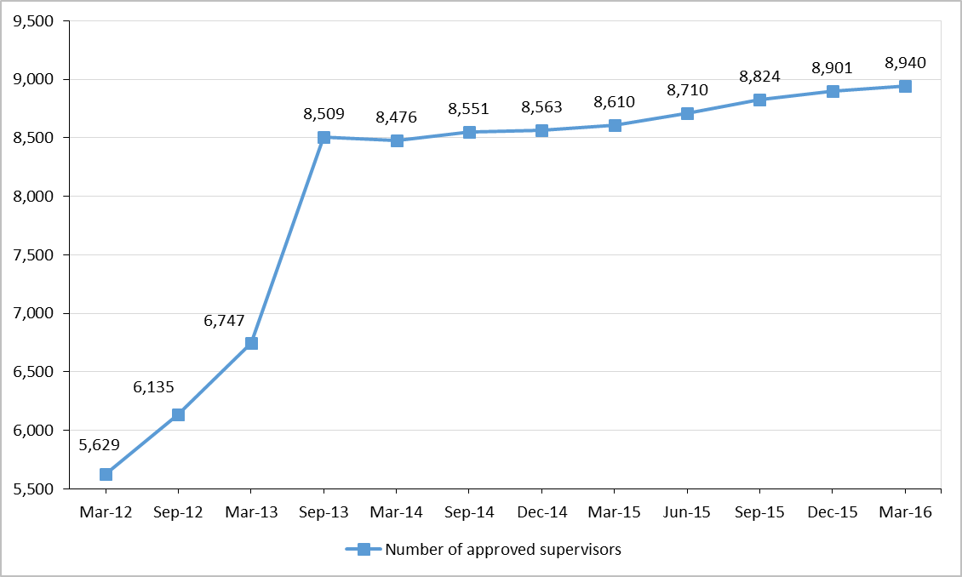

- Registrar program supervisors
  - Registrar program supervisors
PPP | Supervisor Type | Clinical neuropsychology | Clinical psychology | Community psychology | Counselling psychology | Educational and developmental psychology | Forensic psychology | Health psychology | Organisational psychology | Sport and exercise psychology | Any area of practice | Total
ACT | Principal | 5 | 75 |  | 3 | 2 | 4 | 2 | 5 |  |  | 96
 | Secondary | 3 | 42 |  | 2 |  | 1 | 1 | 3 |  | 67 | 119
NSW | Principal | 77 | 861 | 1 | 50 | 53 | 98 | 17 | 48 | 6 |  | 1,211
 | Secondary | 64 | 648 | 1 | 34 | 38 | 78 | 10 | 42 | 2 | 339 | 1,256
NT | Principal | 1 | 8 |  |  |  | 3 |  | 1 |  |  | 13
 | Secondary | 1 | 8 |  | 1 |  |  |  | 1 |  | 7 | 18
QLD | Principal | 39 | 393 |  | 31 | 37 | 33 | 20 | 25 | 8 |  | 586
 | Secondary | 11 | 113 |  | 8 | 11 | 5 | 6 | 11 | 3 | 463 | 631
SA | Principal | 14 | 211 |  | 4 | 15 | 15 | 14 | 17 | 2 |  | 292
 | Secondary | 4 | 87 |  | 4 | 6 | 3 | 5 | 8 |  | 193 | 310
TAS | Principal | 3 | 74 |  | 3 | 11 | 5 | 4 | 1 | 1 |  | 102
 | Secondary | 1 | 56 |  | 1 | 10 | 3 | 2 | 1 |  | 31 | 105
VIC | Principal | 141 | 638 | 17 | 164 | 67 | 51 | 45 | 45 | 5 |  | 1,173
 | Secondary | 84 | 392 | 10 | 90 | 34 | 37 | 35 | 31 | 4 | 446 | 1,163
WA | Principal | 15 | 465 | 2 | 60 | 24 | 21 |  | 11 | 2 |  | 600
 | Secondary | 11 | 295 | 2 | 34 | 10 | 8 |  | 9 | 2 | 229 | 600
No PPP | Principal | 3 | 8 |  | 1 |  | 2 | 1 | 1 |  |  | 16
 | Secondary | 1 | 8 |  |  |  | 2 | 1 | 1 |  | 11 | 24
Total |  | 478 | 4,382 | 33 | 490 | 318 | 369 | 163 | 261 | 35 | 1,786 | 8,315

- Board-approved supervisors of provisional psychologists
  - Approved supervisors by PPP⁵
PPP | 4+2 internship |  | 5+1 program |  | Higher Degree program6 | Work in Addition to Higher Degree7
 | Principal | Secondary | Principal | Secondary
ACT | 206 | 207 | 63 | 66 | 106 | 92
NSW | 2,681 | 2,576 | 851 | 877 | 1,442 | 847
NT | 54 | 58 | 7 | 8 | 19 | 16
QLD | 1,354 | 1,412 | 329 | 337 | 931 | 586
SA | 359 | 358 | 52 | 53 | 314 | 221
TAS | 159 | 161 | 65 | 70 | 111 | 90
VIC | 1,382 | 1,399 | 260 | 262 | 1,517 | 840
WA | 879 | 865 | 149 | 139 | 456 | 322
No PPP | 36 | 33 | 5 | 5 | 27 | 15
Total | 7,110 | 7,069 | 1,781 | 1,817 | 4,923 | 3,029
*Note: The figures in the table above include instances of the same supervisors counted more than once because they are approved to supervise in more than one provisional registration pathway area and/or for both principal and secondary where applicable.

Age group
- Registration type by age group
  - Registration type by age group
Age Group | General | Provisional | Non-practising | Total
U - 25 | 62 | 855 |  | 917
25 - 29 | 2,032 | 1,678 | 84 | 3,794
30 - 34 | 4,022 | 761 | 302 | 5,085
35 - 39 | 3,815 | 417 | 279 | 4,511
40 - 44 | 3,920 | 324 | 195 | 4,439
45 - 49 | 3,128 | 259 | 124 | 3,511
50 - 54 | 2,719 | 169 | 95 | 2,983
55 - 59 | 2,723 | 71 | 125 | 2,919
60 - 64 | 2,369 | 29 | 167 | 2,565
65 - 69 | 1,642 | 9 | 164 | 1,815
70 - 74 | 617 |  | 85 | 702
75 - 79 | 139 |  | 26 | 165
80+ | 60 |  | 10 | 70
Total | 27,248 | 4,572 | 1,656 | 33,476

  - Registrants by age group
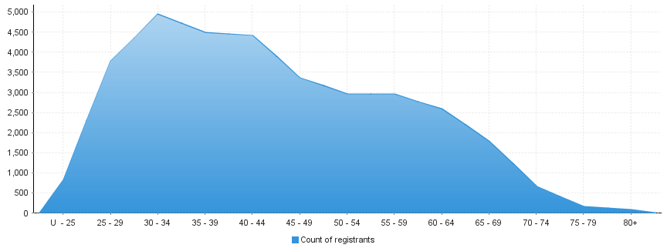

Gender
- Registration type
  - Psychology registrants by gender, by state and territory and by registration type
Gender | Registration type | ACT | NSW | NT | QLD | SA | TAS | VIC | WA | No PPP | Total
Female | General | 588 | 7,140 | 147 | 3,736 | 1,030 | 397 | 5,926 | 2,202 | 271 | 21,437
 | Provisional | 81 | 1,061 | 23 | 792 | 157 | 57 | 1,083 | 489 | 11 | 3,754
 | Non-practising | 26 | 464 | 1 | 226 | 66 | 14 | 289 | 150 | 127 | 1,363
Total female |  | 695 | 8,665 | 171 | 4,754 | 1,253 | 468 | 7,298 | 2,841 | 409 | 26,554
Male | General | 141 | 1,956 | 52 | 1,004 | 354 | 96 | 1,516 | 601 | 91 | 5,811
 | Provisional | 19 | 273 | 6 | 158 | 33 | 6 | 227 | 95 | 1 | 818
 | Non-practising | 12 | 101 | 1 | 47 | 23 | 5 | 50 | 24 | 30 | 293
Total male |  | 172 | 2,330 | 59 | 1,209 | 410 | 107 | 1,793 | 720 | 122 | 6,922
Total |  | 867 | 10,995 | 230 | 5,963 | 1,663 | 575 | 9,091 | 3,561 | 531 | 33,476

- Percentage
  - Registrants by gender percentages
Gender | ACT | NSW | NT | QLD | SA | TAS | VIC | WA | No PPP | Total
Female | 80.16% | 78.81% | 74.35% | 79.72% | 75.35% | 81.39% | 80.28% | 79.78% | 77.02% | 79.32%
Male | 19.84% | 21.19% | 25.65% | 20.28% | 24.65% | 18.61% | 19.72% | 20.22% | 22.98% | 20.68%

3 There were 27,248 psychologists with general registration after the close of business on 31 March 2016. 4 The Board first published national data on the number of approved supervisors in March 2012. Transition provisions for supervisors were in place for the first three years of the National Registration and Accreditation Scheme until 30 June 2013 which contributed to a spike in applications for approval as a supervisor just before new requirements for supervisors commenced on 1 July 2013.
5 Provisional psychologists hold provisional registration which is the registration type under section 62 of the National Law that enables the individual to undertake a period of supervised practice in order to become eligible for general registration. There are different pathways that can be undertaken by registered provisional psychologists including the 4+2 internship program, the 5+1 internship program, and higher degree programs. Refer to the Provisional registration section of the Board’s website www.psychologyboard.gov.au for more information on the pathways. 6 Since 1 July 2013 all supervisors of psychology higher degree students undertaking placements must be approved by the Board.
7 Refer to the Board’s Policy on working in addition to placements.

