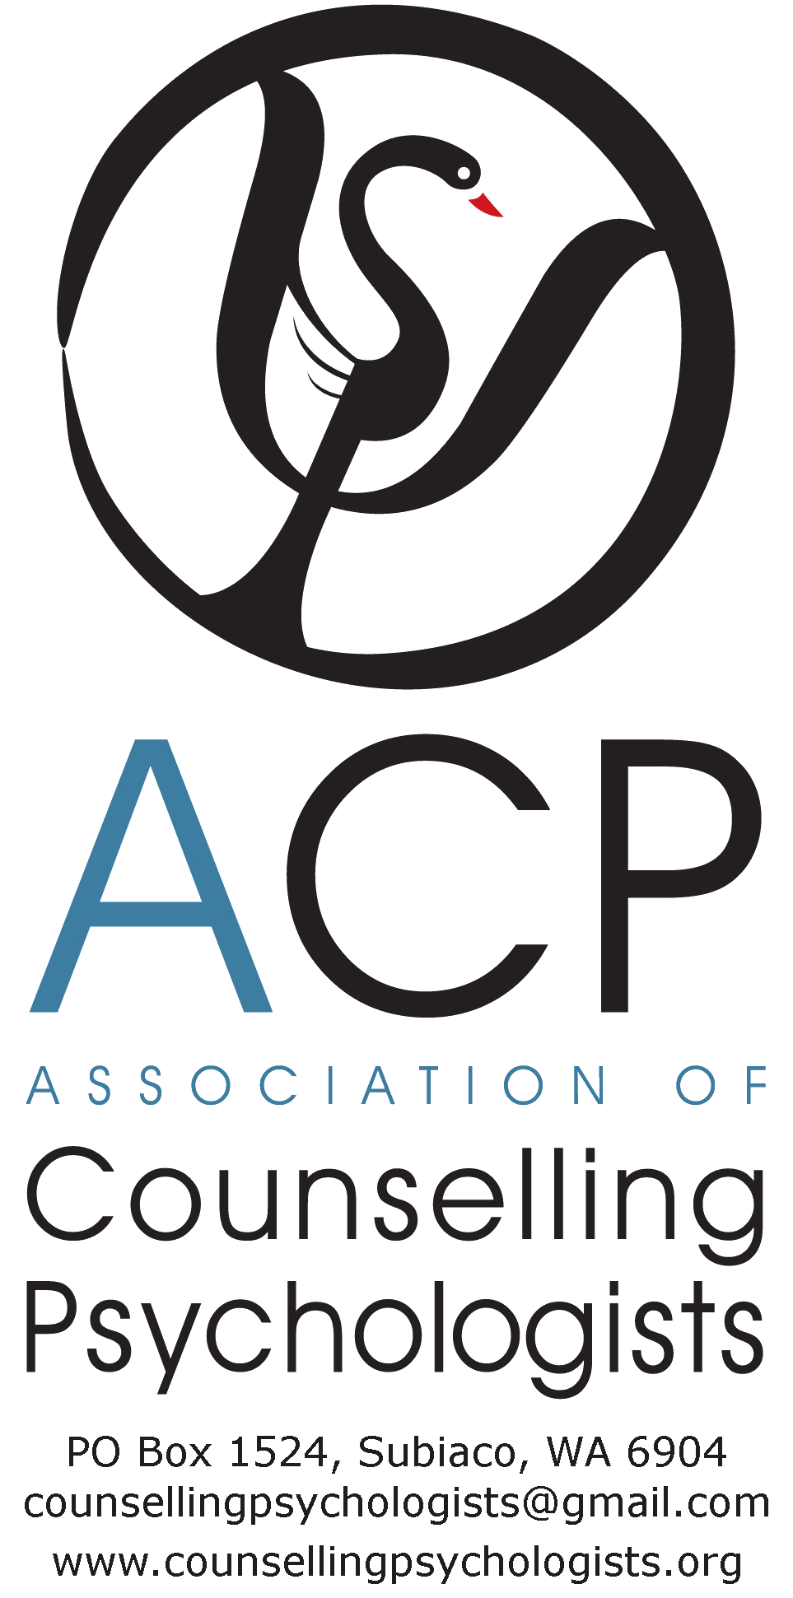
29 February 2016

Psychology Board of Australia
AHPRA
psychconsultation@ahpra.gov.au

Dear Chair and Board members,

RE: CONSULTATION ON REVIEW OF AREA OF PRACTICE ENDORSEMENTS REGISTRATION STANDARD AND GUIDELINES.

Thank you for the opportunity to make a submission to the public consultation on the review of Area of Practice Endorsements Registration Standard and Guidelines. The ACP welcomes the review as an opportunity to resolve the concerns we have repeatedly expressed since the introduction of the national registration scheme in 2010, and the associated consultations that resulted in the current guidelines in 2011.

As you are aware, the ACP strongly objects to the current and proposed guidelines on competencies required for counselling psychology endorsement, as outlined in Appendix B of the draft guidelines (pp.24-25). Our primary objections are that the guidelines do not address the issues we have raised since 2010 and they do not accurately reflect the core competencies of Counselling Psychologists:

- attained through Masters or doctorate qualifications in counselling psychology;

- achieved through completion of the registrars’ program for endorsement as a Counselling Psychologist;

- applied in the treatment of a broad spectrum of mental health issues across the lifespan; or

- practised in the variety of settings in which Counselling Psychologists work.

In particular, the guidelines do not give due recognition to counselling psychology competencies in psychological assessment, case formulation, diagnosis, knowledge of psychopathology and psychopharmacology, evidence-based treatment of mental disorders, and couple therapy.

The guidelines mistakenly include reference to competence in community interventions; thus confusing the role of Counselling Psychologists with that of Community Psychologists.

The ACP considers that the preamble to the eight specialist skills and capabilities that Counselling Psychologists must possess is a narrow and inaccurate depiction of the nature of contemporary counselling psychology practice, suggesting that our focus is ‘fulfilment’, ‘productivity’, and ‘growth’, and downplaying the severity of our clients’ presentations and mental health conditions for which they seek treatment.

The ACP believes that the guidelines are important to protect the public, define our professional identity, and distinguish between the nine areas of advanced psychology practice. However, the ACP is concerned that as the current and proposed guidelines stand:

- they mislead clients and third-party referrers about the respective competencies of the nine psychology streams. In particular, they imply that Counselling Psychologists are less competent than Clinical Psychologists in assessment, diagnosis and treatment of mental disorders. As a result clients potentially conclude incorrectly that Counselling Psychologists are unqualified to meet their mental health care needs. This is a significant restriction on consumer choice, given that Counselling Psychologists are the second largest group of advanced psychology practitioners in Australia.

- employers will base recruitment decisions on inaccurate descriptions of the expertise of Counselling Psychologists. This will result in restricted public access to the skills of Counselling Psychologists and services offering less diverse mental health teams. It will also disadvantage Counselling Psychologists in their efforts to find work or seek promotion, which in turn could affect students’ choices about future courses of study in advanced psychology. We note that two APAC-accredited courses in counselling psychology have closed since the current guidelines were implemented, leaving only one dedicated counselling psychology program in Australia.

- they could adversely affect mobility of Australian Counselling Psychologists because they are out of alignment with internationally recognised competencies of Counselling Psychologists. Likewise, they could deter internationally trained Counselling Psychologists from coming to Australia.

Given the above, the ACP contends that the current and proposed guidelines do not comply with COAG Principles for Best Practice Regulation, specifically principles 1, 2 and 3, relating to protection of the public, restriction of competition among health practitioners, and restriction of consumer choice.

I commend to the Board the attached submission and proposed revisions to the guidelines, which have been agreed by the Association of Counselling Psychologists, the APS College of Counselling Psychologists, and the Curtin University counselling psychology program. I urge the Board to give proper consideration to submitting these to the Ministerial Council for approval.

The ACP looks forward to seeing revised guidelines that accurately portray the expertise of Counselling Psychologists to the public/consumers, the psychology profession, other mental health professionals, and prospective students of counselling psychology.

If you require further information or wish to discuss the matters raised in our submission, please contact me on 0439 549 481 or email counsellingpsychologists@gmail.com

Yours sincerely,

Fiona Carberry
Chair
BA, BSW, B.Psych. M.Psych. (Counselling Psych.), MA (Public Policy)

