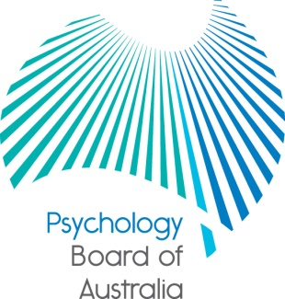

Communiqué

27 November 2015

The Psychology Board of Australia (the Board) is established under the Health Practitioner Regulation National Law, as in force in each state and territory (the National Law). At each meeting, the Board considers a wide range of issues, many of which are routine and are not included in this communiqué.
This communiqué highlights key issues from the 69th meeting of the Board on 27 November 2015.
Consultation update
The Board will soon start public consultation and call for submissions on its proposed revised Area of practice endorsement registration standard and guidelines.

Consultation is an important part of the Board’s engagement with psychologists and members of the public. Feedback received is highly valued, and informs the Board’s development of registration standards, codes, and guidelines.

To read new and past consultation papers go to the Board’s website under the News tab.

Newsletter
The Board has released Issue 15 of its Connections newsletter. You can read this in the Newsletters section of the Board’s website.

Approved programs of study
Under section 49 of the National Law, the National Board requires accreditation reports from the Australian Psychology Accreditation Council (APAC) before approving the accredited programs of study as providing a qualification that will lead to registration.

At this meeting the Board approved APAC-accredited courses at the Australian College of Applied Psychology, Cairnmillar Institute, Deakin University, Federation University, University of Southern Queensland, University of New England, and Queensland University of Technology.

The Board also approved the discontinuation of a number of courses across the country in accordance with section 51(2) of the National Law, including courses at Victoria University, Western Sydney University, University of Western Australia, University of Southern Queensland, University of Wollongong, University of New South Wales, University of New England, University of Newcastle, University of Adelaide, Southern Cross University, RMIT, Macquarie University, James Cook University, Federation University, Flinders University, Griffith University, Central Queensland University, Charles Darwin University, University of Canberra, Bond University, Australian Catholic University and Australian College of Applied Psychology.

An updated list of Board-approved qualifications will soon be published under Accreditation on the Board’s website.

National drug screening protocol
From November 2015, all psychologists who have restrictions placed on their registration by the Board as a result of past substance misuse will have routine quarterly hair testing, in addition to random urine testing.

The introduction of routine hair testing is based on expert advice about modern screening methods. Routine hair testing helps provide comprehensive information about the use – over time – of a wide range of drugs (not just based on the practitioner’s drug taking history).

The drug screening protocol is part of a wider, national strategy to effectively manage compliance and monitoring across the National Registration and Accreditation Scheme. More information is in the statement published on the Board’s website.

Professor Brin Grenyer
Chair
Psychology Board of Australia
7 December 2015

The Health Practitioner Regulation National Law, as in force in each state and territory

